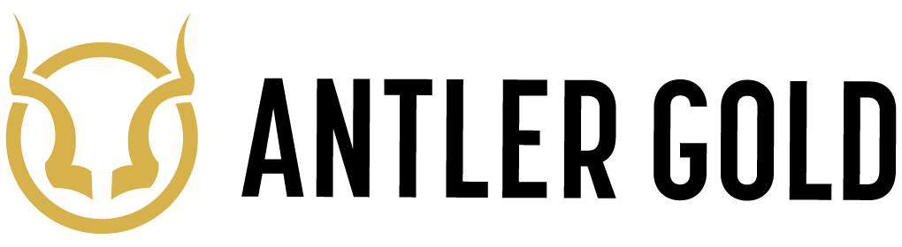

ANTLER GOLD INC. ANNOUNCES APPOINTMENT OF NEW DIRECTOR

HALIFAX, NS, November 10, 2020 – Antler Gold Inc. (TSXV:ANTL) (“Antler Gold” or the “Company”) is pleased to announce that it has appointed Mr. Dale Verran, P.Geo., M.Sc. Exploration Geology to its Board of Directors effective immediately.

Mr. Verran has over 20 years of international experience in the mining and mineral exploration industry and currently serves as the CEO of Fortune Bay Corp. (TSXV:FOR, Frankfurt: 5QN), a gold-focused exploration and development company. He has previously served as Vice President, Exploration for Denison Mines Corp., Executive Technical Director for Remote Exploration Services (Pty) Ltd., and as Exploration Manager for Manica Minerals Limited.

Mr. Verran has extensive work experience in Namibia over a 12-year period where he was involved with discoveries including the Omitiomire Copper Deposit (International Base Metals Limited), the Kaudom South kimberlites (Motapa Diamonds Inc.), and the Marble Ridge Uranium Zone (Pitchstone Exploration Ltd.). Mr. Verran has an intimate knowledge of Namibian geology through his post-graduate studies and has taught the M.Sc. Course in Exploration Geochemistry at the University of Namibia.

Antler also announces that it has granted 250,000 incentive stock options under the Company’s Stock Option Plan ("Plan") to Mr. Verran. Each option is exercisable into one common share at a price of $0.30 per share and will vest at the rate of 50% of the total on each of the six and twelve month anniversary of the grant date. The options will expire five years from the date of grant. All other terms and conditions of the options are in accordance with the terms of the Plan.

About Antler Gold Inc.

Antler Gold Inc. (TSXV: ANTL) is a Canadian company, focused on the acquisition and exploration of gold projects in Namibia. Antler’s Erongo Gold Project covers areas of the Navachab-Damara Belt, which is highly prospective for gold, and overlies similar lithologies and structures as the known Namibian Gold mines (QKR’s Navachab and B2 Golds’ Otjikoto) as well as Osino’s recent Twin Hills discovery. Antler’s total license position now comprises five licenses (EPL 5455, 6162, 7261, 6550 and 6408) under option and a further five (EPL 7854, 7930, 7960, 8010 and 8042) under application, for a total landholding of approximately 85,341ha (853.41km²). Antler is currently focusing its efforts on advancing its Erongo Gold Project, which is located approximately 130 km north-west of Namibia’s capital city Windhoek and benefits from Namibia’s well-established infrastructure of paved highways, railway, power and water. Namibia is mining-friendly and lauded as one of the continent’s most politically and socially stable jurisdictions. Antler continues to evaluate new ground with a view to expanding its Namibian portfolio.

Cautionary Statements

This press release may contain forward-looking information, such as statements regarding the vesting and expiry of options granted. This information is based on current expectations and assumptions (including assumptions relating to general economic and market conditions) that are subject to significant risks and uncertainties that are difficult to predict. Actual results may differ materially from results suggested in any forward-looking information. Antler does not assume any obligation to update forward-looking information in this release, or to update the reasons why actual results could differ from those reflected in the forward-looking information unless and until required by securities laws applicable to Antler. Additional information identifying risks and uncertainties is contained in the filings made by Antler with Canadian securities regulators, which filings are available at www.sedar.com. Neither TSX Venture Exchange nor its Regulation Services Provider (as that term is defined in policies of the TSX Venture Exchange) accepts responsibility for the adequacy or accuracy of this release.

For further information, please contact Daniel Whittaker, President and CEO of Antler Gold Inc., at (902) 488-4700. Further details are available on the Company's website at www.antlergold.com.

